FREE SRJC RESOURCES - Only for SRJC students enrolled in a Spring 2021 class
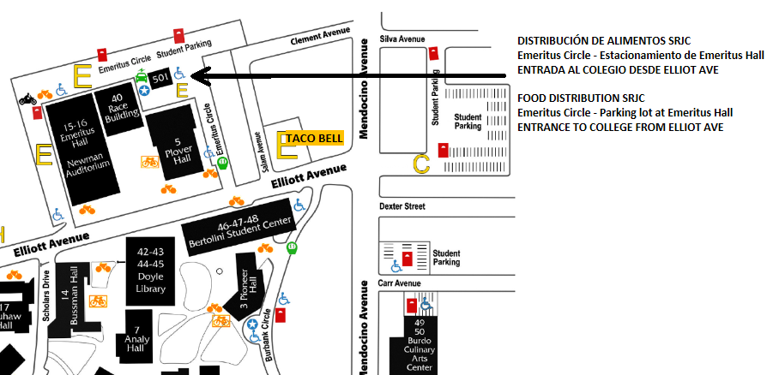
SRJC Food distribution and $50 gift card give away Free to all current students. Please bring your student ID number and a valid photo ID. It is not necessary to make a reservation, just show up.

Monday, April 5th, 2021 from 9am-11am –
Monday, May 3rd, 2021 from 9am-11am
SRJC, Emeritus Circle, Parking Lot, Santa Rosa, Ca

SWC $25 Food card give away - Free to all current noncredit students. Please call 707-527-4229 to sign-up and bring your student ID number and a valid photo ID to the distribution event.

Free Remote Student Health Services
For appointments call 707-527-4445, M-Th 8:30am-5pm, Fri 8:30-2pm or email studenthealthservices@santarosa.edu
Physical Health Services: support for short-term acute illnesses, injuries, infections, rashes and health care advice.
Mental Health Services: support with stress, anxiety, depression, sleep difficulties etc.

Covid Emergency Grants
Financial assistance to current students in need - including noncredit and undocumented students - to help cover COVID-19 school-related expenses such as course materials (books), technology (laptop, tablet, internet), housing (rent and utilities), food, health care (including mental health) and child care.
Fill out an application at https://financialaid.santarosa.edu/srjc-student-emergency-grant
If your application is approved, you will receive an email.

FREE RESOURCES IN THE COMMUNITY for everyone
The resources listed below are only for informational purposes. The SRJC does not take any responsibility for their accuracy or validity.

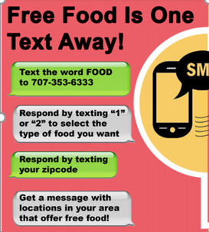
Face Masks Call 707-837-9577
Covid 19 Testing Call 707-565-4667 M-F 8am-8pm.
Food Text “FOOD” to 707-353-6333

Food distribution in Santa Rosa
Saturday, March 20th, 2021 – 10am-12pm - Santa Rosa High School –
ArtQuest Office and Media Center - 1075 Mendocino Ave

Mental Health Services (Sonoma County) Call 707-565-2652

Free Diapers
CPI – Child Parent Institute - offers free diapers twice a month. Information at https://calparents.org/ - Diaper Project –
or call (707) 585-6108. People in need have to fill out a form each time.

